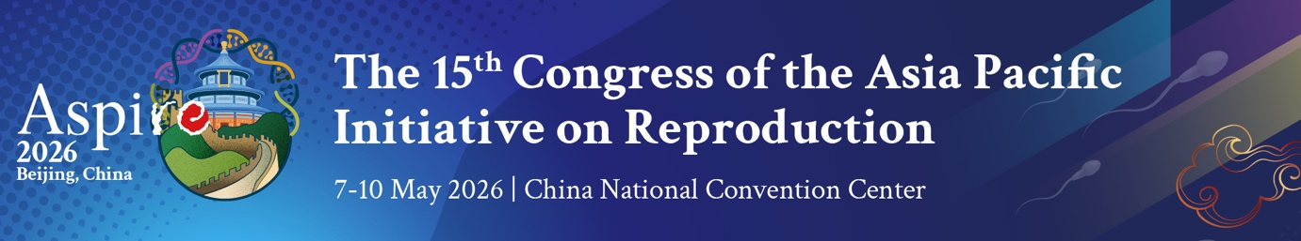

Psychosocial support is vital to help those living with infertility to overcome treatment barriers, including stigmas, myths and taboos about IVF

Media Release, 9 May 2026

Diverse cultural or religious values across the Asia Pacific region mean that many people living with infertility face challenging family or societal attitudes when considering assisted reproductive treatment to achieve their dreams of parenthood.

In many cases infertility generates personal shame and feelings of failure, as well as pressure to maintain family lineage with stigma compounding distress and depression over the struggle to conceive.

In some societies with conservative cultural or religious views, fertility treatments such as IVF are viewed with suspicion and are often associated with myths and taboos.

Globally, one in every six couples experience infertility, which is defined as the failure to conceive after a year of unprotected intercourse, or the inability to carry pregnancies to a live birth. The causes of infertility are equally shared between male and female partners.

The problem is particularly relevant in many APAC countries where birth rates have fallen below population replacement levels creating disturbing socio-economic forecasts about dependencies of ageing populations.

The importance of integrated psychological care for people seeking assisted conception is a major focus of the 2026 Congress of the Asia Pacific Initiative on Reproduction (ASPIRE) being held in Beijing.

Speaking at the Congress, clinical psychologist Associate Professor Sonja Goedeke, said infertility was simultaneously a medical condition and a profound life crisis.

“Furthermore, assisted reproductive treatments may be characterised by prolonged uncertainty, physical burden, relational strain, and repeated exposure to potential loss,” she explained. “Psychological distress – most commonly anxiety, depression, and infertility-related stress – is highly prevalent and not confined to those with pre-existing mental health difficulties.

“Psychological care is not simply an optional adjunct, but an essential component of patient-centred, evidence-based fertility treatment. By providing accurate, evidence-based information and support counsellors can help people feeling overwhelmed.
…2/
2

“Psychological care also strengthens emotional regulation, coping capacity, relational communication, and decision-making, supporting patients to engage more fully in informed consent and complex treatment choices.

“Hearing about other people's experiences and research evidence can address issues of shame and isolation. Professional counselling assists individuals and couples to clarify their values and make decisions in the face of external pressure such as when families hold strong expectations about genetic relatedness or traditional family formation.

“It includes strategies to manage ethical, cultural and identity considerations.”

Sonja Goedeke is an Associate Professor in the Department of Psychology and Neuroscience at Auckland University of Technology. Her research centres on the psychosocial and ethical dimensions of infertility and assisted reproduction.

She told the ASPIRE Congress: “The central message is clear. Psychological care does not guarantee pregnancy, but it improves the conditions in which successful treatment can occur.

“Integrating routine, responsive psychosocial services into fertility clinics is therefore both clinically justified and ethically imperative.”

Associate Professor Goedeke said despite its evidence-based benefits in assisted reproductive treatment, psychosocial care remains inconsistently integrated into fertility services in the Asia Pacific.

“Barriers can be addressed at several levels, beginning with increasing awareness of why psychosocial care is integral to best-practice assisted reproduction, including its role in decision-making, emotional wellbeing, and long-term family outcomes.

“ASPIRE has taken an important step in this regard through the establishment of its Psychology and Counselling Special Interest Group, which provides professional development opportunities such as webinars and educational talks that are open to all healthcare professionals.”

The ASPIRE Congress at the China National Convention Centre in Beijing has attracted almost 3,000 scientists, clinicians, nurses and counsellors specialising in assisted reproduction.

For further information on the ASPIRE 2026 Congress, go to https://www.aspire2026.com

Interview

Associate Professor Sonja Goedeke is available for interview.
To arrange, please contact Trevor Gill, ASPIRE Congress Media Relations.
Tel: (Australia) 61 418 821948 or email lighthousepr@adelaide.on.net

